Experiment 14: Design Turing Machine (TM) Using Simulator to Accept a Palindrome String
Aim
To design and simulate a Turing Machine (TM) that accepts palindrome strings over the alphabet {a, b}.
A palindrome is a string that reads the same forwards and backwards.
Example: ababa

Algorithm
- Start from the leftmost symbol of the input string.
- Mark the first unmarked symbol (a or b).
- Move to the right end of the string.
- Find the last unmarked symbol and compare it with the first marked symbol.
- If both symbols match, mark the last symbol.
- Return to the beginning of the tape.
- Repeat the process for the remaining unmarked symbols.
- If all symbols are successfully matched, accept the string.
- If any mismatch occurs, reject the string.

Procedure
- Open the Turing Machine simulator (e.g., JFLAP).
- Create the required states.
- Mark the initial state as the start state.
- Replace the first unmarked symbol with a marker (X for a, Y for b).
- Move to the rightmost unmarked symbol and compare it.
- If the symbols match, mark the last symbol.
- Return to the beginning and repeat until all symbols are marked.
- If all symbols are matched successfully, move to the accept state; otherwise, move to the reject state.
- Run the simulator using the palindrome input string.

Input
ababa

Output
Input : ababa
Output : Accepted
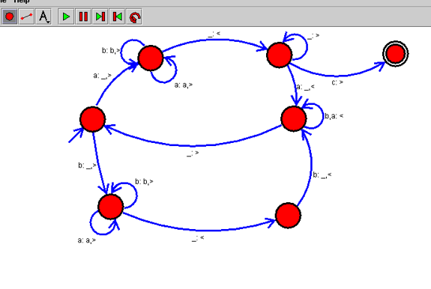

Result
Thus, the Turing Machine (TM) was successfully designed and simulated to accept the palindrome string "ababa". The simulator correctly accepted the input, verifying that it is a valid palindrome.

